**PROJECT REPORT**

**INTRODUCTION**

* 1. **Overview:**

India is the world’s third-largest producer and third-largest consumer of electricity. The national electric grid in India has an installed capacity of 370.106GW as of 31st March 2020. Renewable power plants, which also include large hydroelectric plants, constitute 35.86% of India's total installed capacity. During the fiscal year (FY) 2019–20, the total electricity generation in the country was 1,598 TWh, of which 1,383.5 TWh generated by utilities. The gross electricity consumption per capita in FY2019 was 1,208 kWh. In 2015-16, electric energy consumption in agriculture was recorded as being the highest (17.89%) worldwide. The per capita electricity consumption is low compared to most other countries despite India having a low electricity tariff. In light of the recent COVID-19 situation, when everyone has been under lockdown for the months of March to June the impacts of the lockdown on economic activities have been faced by every sector in a positive or a negative way. The dataset is exhaustive in its demonstration of energy consumption state wise. Analyzing Electricity Consumption in India from Jan 2019 till 5 Th December 2020. This dataset contains a record of Electricity consumption in each states of India, here we are going to analyze State wise , Region wise and Overall Electricity consumption in India is the world's third-largest producer and third-largest consumer of electricity. The national electric grid in India has an installed capacity of 370.106 GW as of 31 March 2020. Renewable power plants, which also include large hydroelectric plants, constitute 35.86% of India's total installed capacity. During the fiscal year (FY) 2019–20, the total electricity generation in the country was 1,598 TWh, of which 1,383.5 TWh generated by utilities. The gross electricity consumption per capita in FY2019 was 1,208 kWh. In 2015-16, electric energy consumption in agriculture was recorded as being the highest (17.89%) worldwide. The per capita electricity consumption is low compared to most other countries despite India having a low electricity tariff. In light of the recent COVID-19 situation, when everyone has been under lockdown for the months of March to June the impacts of the lockdown on economic activities have been faced by every sector in a positive or a negative way. The dataset is exhaustive in its demonstration of energy consumption state wise. Analyzing electricity consumption in India from Jan 2019 till 5th December 2020. This dataset contains a record of Electricity consumption in each states of India, here we are going to analyze State wise, Region wise and Overall Electricity consumption in India.

**1.2PURPOSE**

* Economic growth in developing countries, and electrification of transport and heating.
* People use electricity for lighting, heating, cooling and refrigeration and for operating appliances, computers, electronics, machinery, and public transportation systems.
* Quickly increasing this share by further electrification is extremely important to limit climate change, because most other energy is consumed by burning fossil fuels thus emitting greenhouse gases which trap heat.
* Combustion engine are replaced by electric drive and for heating less gas and oil, but more electricity is used, if possible with heat pumps.
* Electricity has been generated in power stations since 1882. The invention of the steam turbine in 1884 to drive the electric generator lead to an increase in worldwide electricity consumption.

**2. Problem definition and design thinking**

**2.1 Empathy map**

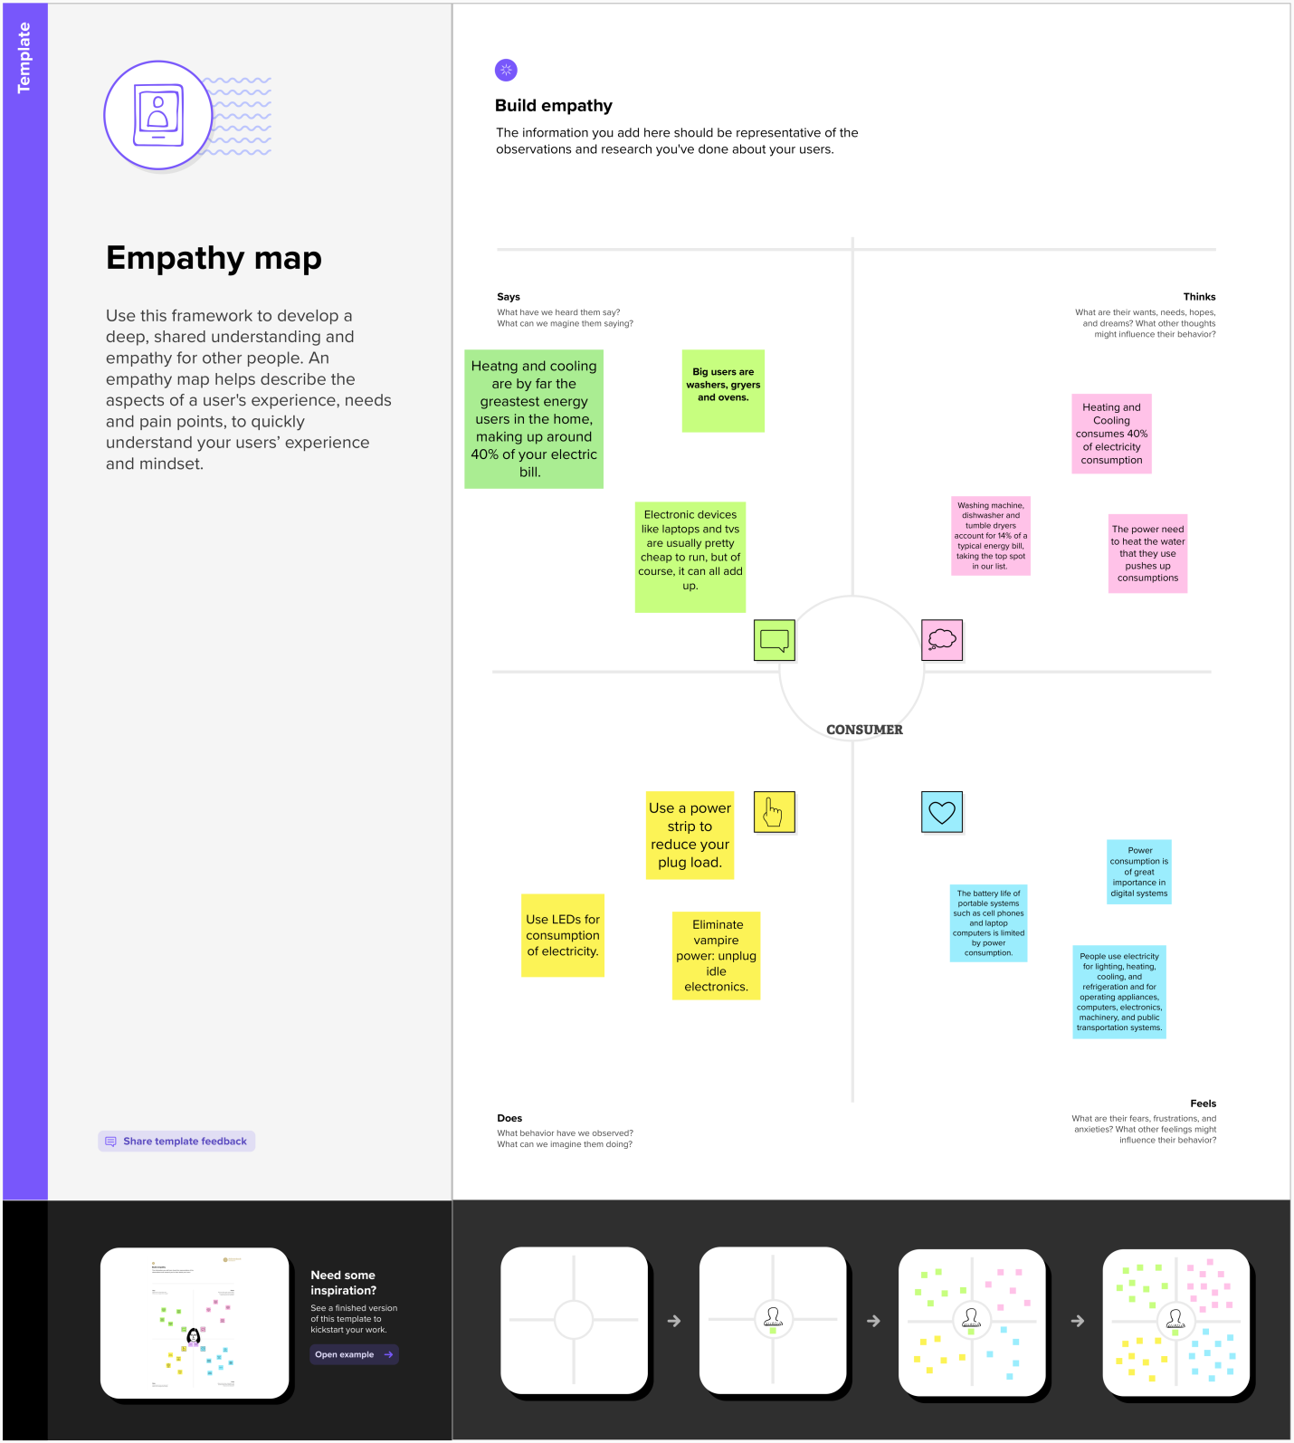

**2.2 Ideation & brainstorming**

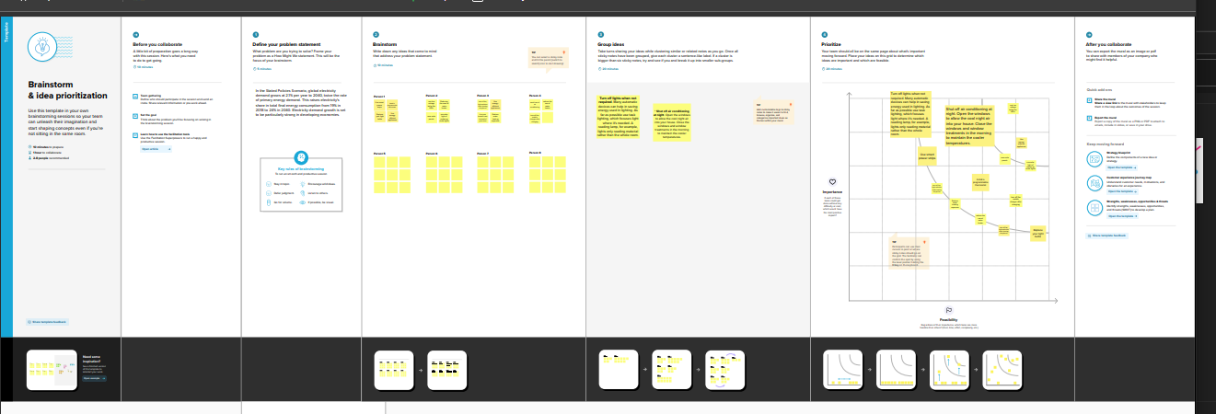

**3. RESULT**

**3.1 2019 STATE CONSUMPTION**

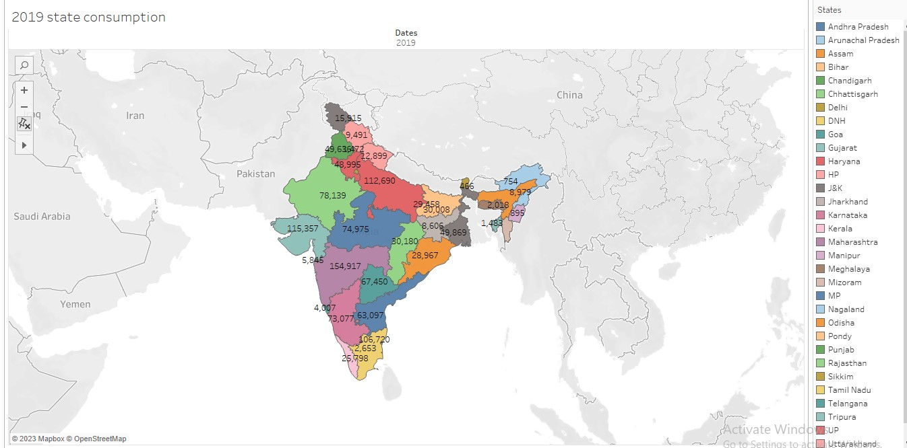

**3.2 2020 STATE CONSUMPTION**

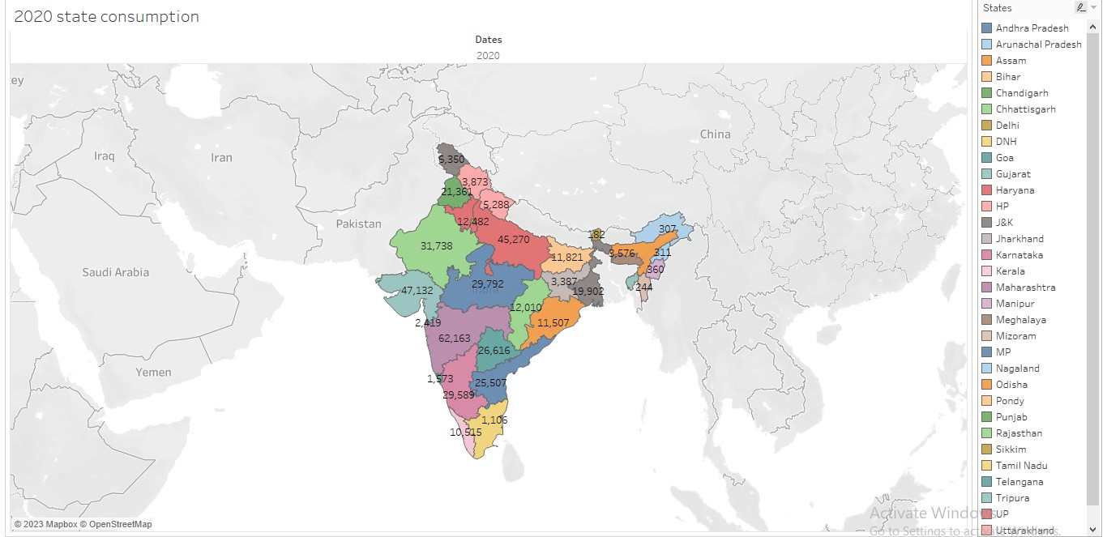

**3.3 2019 MONTHWISE CONSUMPTION**

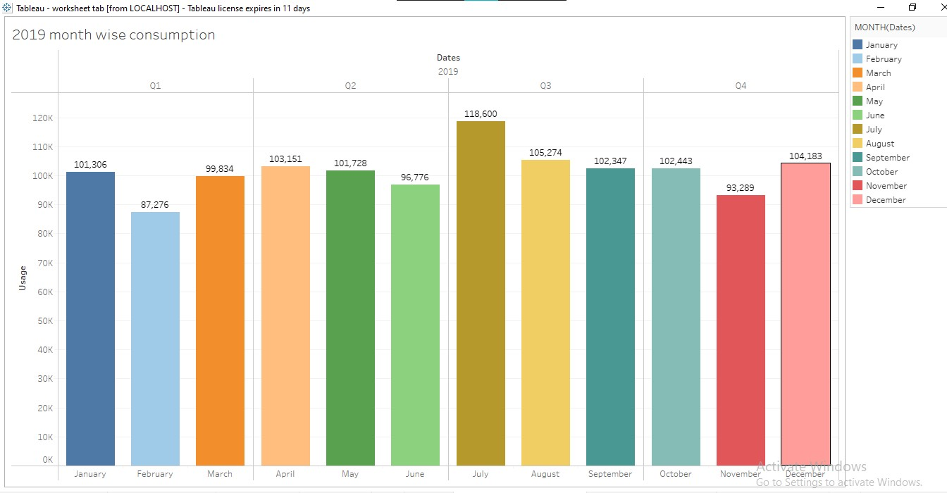

**3.4 2020 MONTHWISE CONSUMPTION**

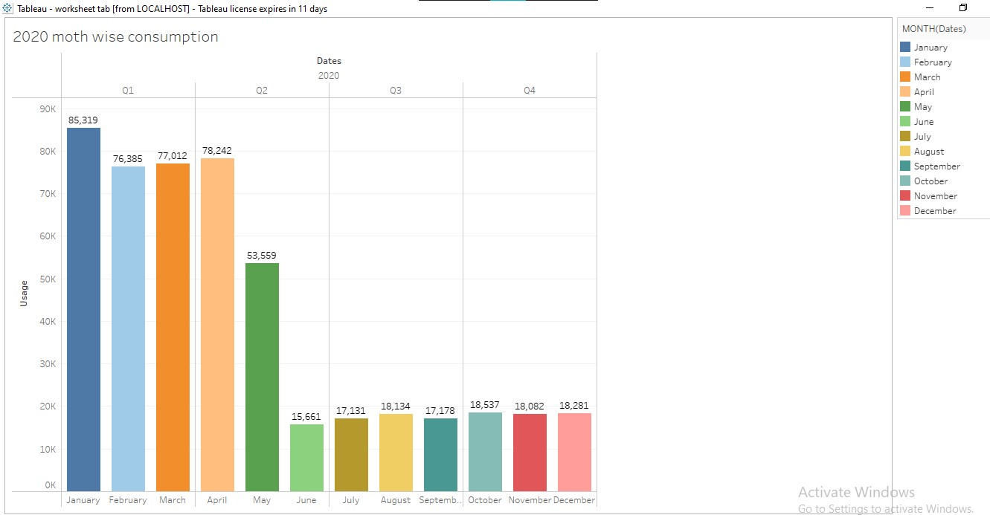

**3.5 BOTTOM N**

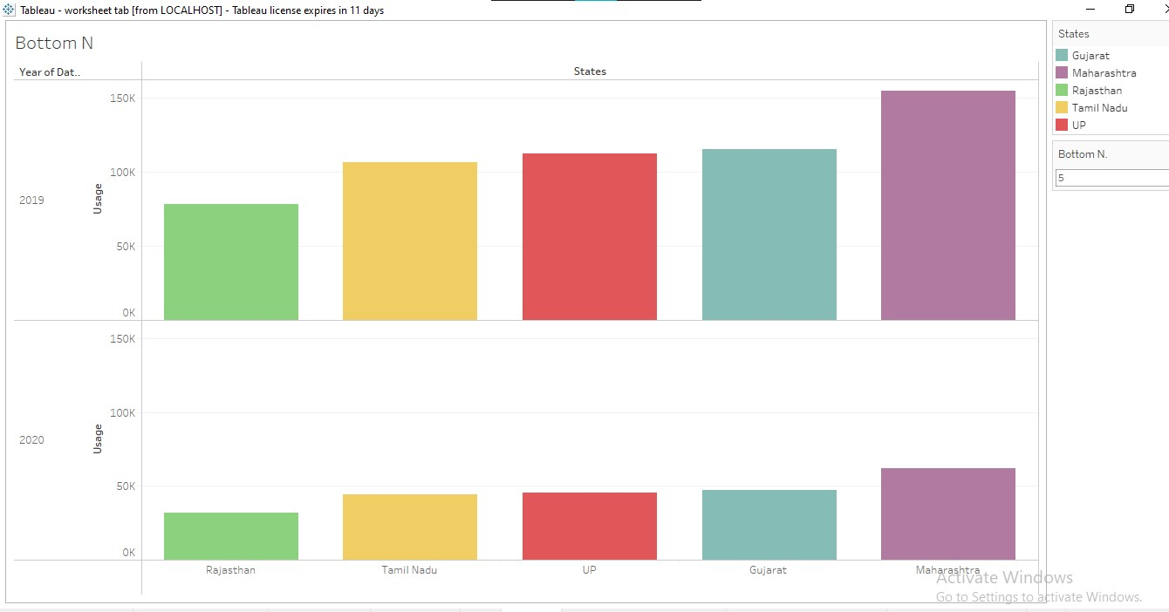

**3.6 TOP N**

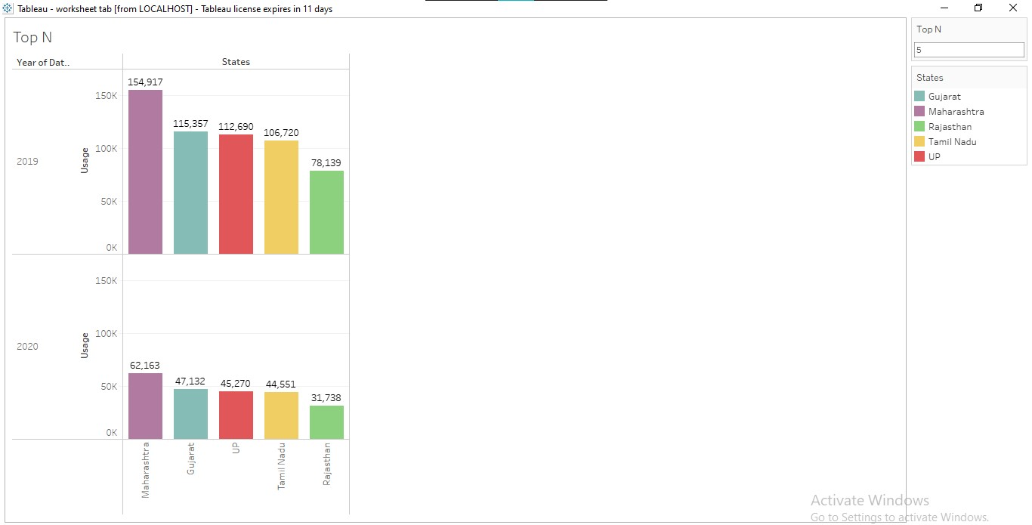

**3.7TOTALCONSUMPTION** 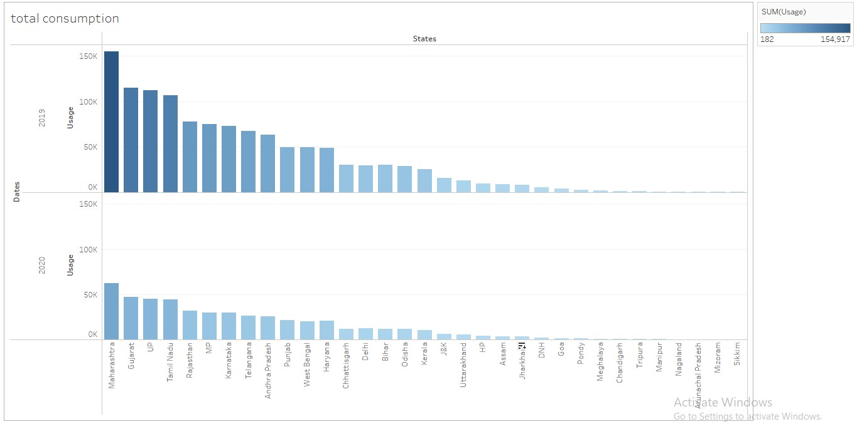

**3.8 USAGE BY CONSUMPTION**

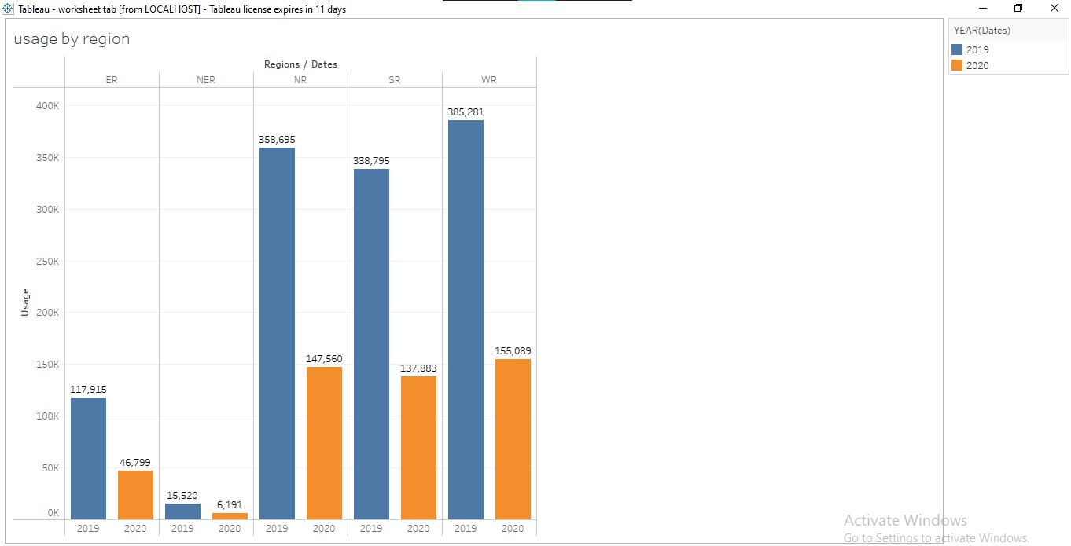

**3.9 REGIONWISE STATE CONSUMPTION**

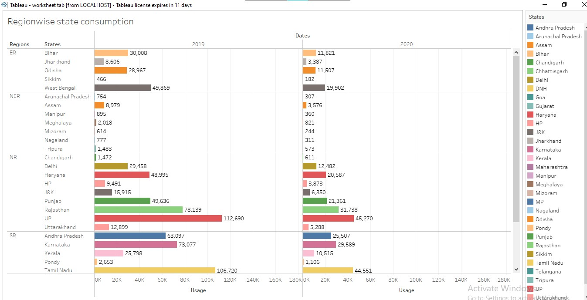

**3.10 QUARTER WISE USAGE**

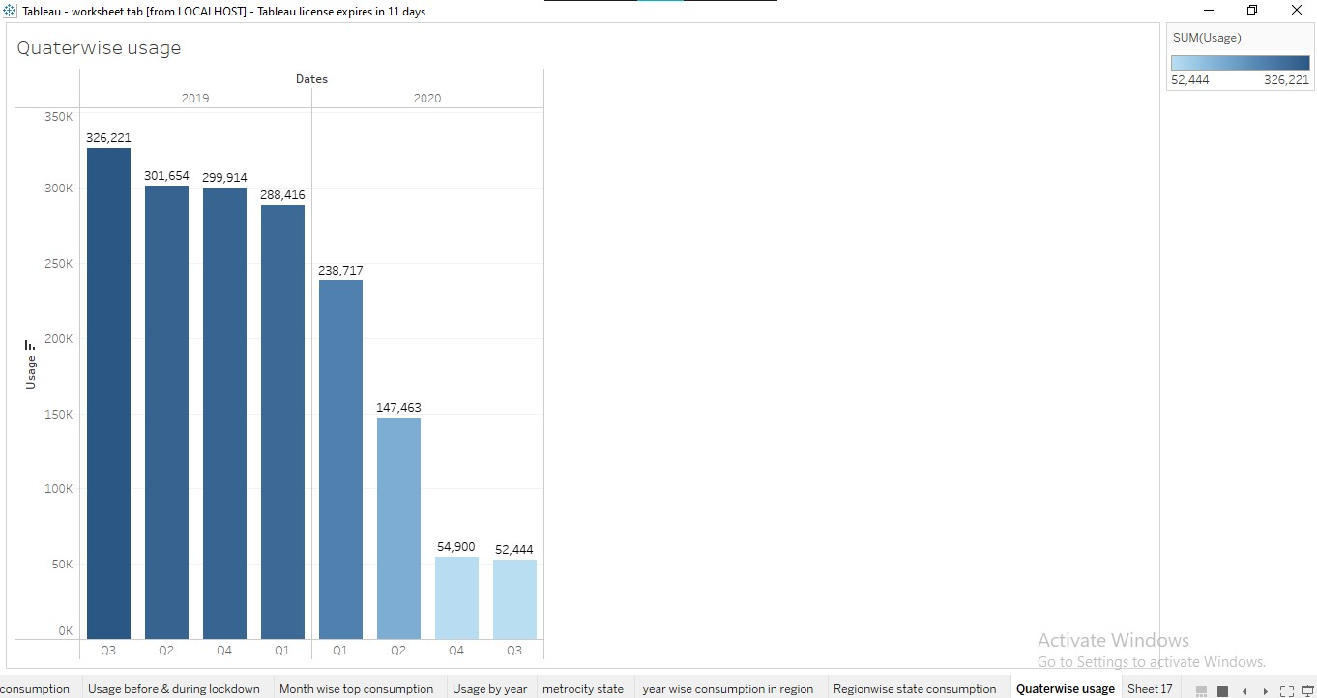

**4. ADVANTAGES AND DISADVANTAGES**

**4.1 ADVANTAGES**

* Electricity consumption is a clean, safe, cheap and convient source of energy. Lower maintenance of cost.
* Electricity consumption grows faster when the industrialization process develops quickly and goes down rapidly when industrialization is completed or near completion.
* Its reliable and uninterrupted supply runs the equipment efficiently and continuously.
* Energy efficiency can provide long-term benefits by lowering overall electricity demand.

**4.2 DISADVANTAGES**

* More expensive than gasoline.
* Loss of fish species
* Cost for construction
* Damming can cause loss of land suitable for agriculture as well as recreation.

**5. APPLICATIONS**

* Use electricity for lighting, heating, cooling, and refrigeration and for operating appliances, computers, electronics and public transportation systems.
* Heating and cooling our homes
* Lighting office buildings.

**6. CONCLUSION**

* Maharashtra is the highest electricity consumption user in India.
* Gujarat is the second highest electricity consumption user of India.
* Sikkim is the lowest electricity consumption user of India.

**7. FUTURE SCOPE**

India’s energy demand was projected to increase by almost 50% between 2019 and 2030, but growth over this period is now closer to 35% in the steps, and 25% in the delayed recovery scenario.

In the stated policies scenario, global electricity demand grows at 21% per year to 2040, twice the rate of primary energy demand. This raises electricity’s share in total final energy consumption from 19% in 2018 to 24% in 2040.